Lower Limb Orthosis
- University of California Berkley Orthosis (UCB)
- Supramalleolar Orthosis (SMO)
- Ankle Foot Orthosis (AFO)
- Knee Orthosis (KO)
- Knee Ankle Foot Orthosis (KAFO)
- Hip Knee Ankle Foot Orthosis (HKAFO)
- Reciprocating Gait Orthosis (RGO)
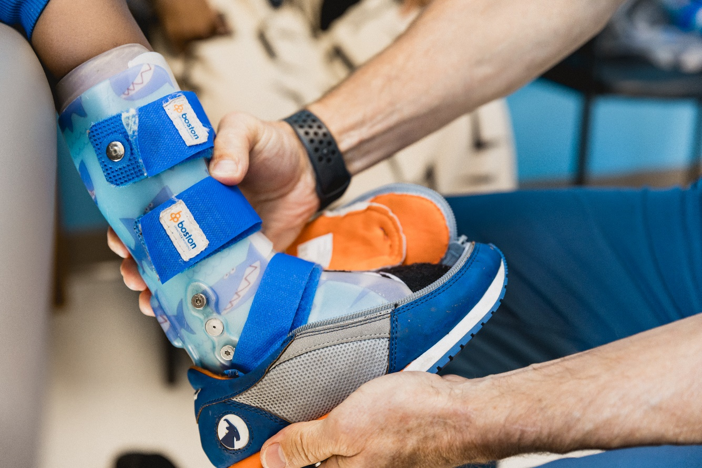

  Boston Brace International, Inc.  37 Shuman Ave  Stoughton, MA 02072 USA  www.bostonoandp.com | 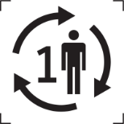   | 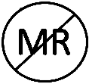  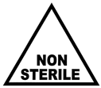

ENGLISH
PRODUCT DESCRIPTION
The Lower Limb Orthosis, including University of California Berkley Orthosis (UCB), Supramalleolar Orthosis (SMO), Ankle Foot Orthosis (AFO), Knee Orthosis (KO), Knee Ankle Foot Orthosis (KAFO), Hip Knee Ankle Foot Orthosis (HKAFO), Reciprocating Gait Orthosis (RGO), is a rigid and/or semi-rigid device used for the purpose of supporting or restricting motion in a weak, irregularly formed, diseased, or injured part of the body. The orthoses are patient matched fabricated used to treat a neuromusculoskeletal disorders or acquired conditions.

MATERIALS
The Lower Limb Orthosis is made from various types of metal and plastic materials. The materials include low density polyethene, co-polymer, polypropylene, carbon fiber, acrylic resin, aluminum, nickel plated brass, nylon, pressure sensitive adhesive, polyethylene foam, crosslinked polyolefin foam, and hook-and-loop fasteners.

INTENDED USE
The Lower Limb Orthosis is intended to improve or correct lower limb issues by providing support to the limb, improving alignment, controlling motion, minimizing pain, and correcting or preventing the progression of deformity.

INDICATIONS FOR USE
The Lower Limb Orthosis is intended to improve or correct lower limb issues by providing support to the limb, improving alignment, controlling motion, minimizing pain, and correcting or preventing the progression of deformity.

CONTRA-INDICATIONS
Do not use the Lower Limb Orthosis in the presence of any contraindication. Contraindications include but are not limited to:
- Material sensitivity documented or suspected.
- Inability to follow treatment protocol and care instructions.

WARNINGS AND PRECAUTIONS
- Federal Law restricts the Lower Limb Orthosis to sale by, or on the order of, a qualified physician or healthcare provider and is only to be used as prescribed.
- The orthosis that encompasses the foot and ankle is designed to be worn with shoes. Wearing the orthosis that encompasses the foot and ankle without shoes:
  - Will negatively impact the functional benefits the orthosis.
  - Will put you at significant risk for slips and falls.
  - Can damage the orthosis (which are not covered under warranty).
- It is important to prevent skin irritation, such as soreness, redness, or rashes while wearing your orthosis.
  - Always wear a barrier (e.g. leg/foot sock) under the orthosis to protect the skin.
  - Make sure there are no wrinkles in the sock before putting on the orthosis.
  - If you notice areas of redness that do not fade after 30 minutes after the orthosis is removed or are causing pain, blistering, or bruising, please consult your healthcare provider.
  - Improper fit, wrinkled, damp, dirty and/or lack of barrier protection between the product and intact skin may create a risk of irritation, soreness, redness, blisters, or pressure ulcers.
  - Be sure to wear your orthosis tightly. A loose-fitting orthosis may create a risk of chaffing and/ or impact device performance and outcomes.
  - Lack of routine cleaning, leaving soil on device, may allow for microorganism growth.
- Contact your orthotist if any of the following issues arises:
  - Any redness or irritation that does not go away within 30 minutes after removing the orthosis.
- Complaints of discomfort after the break-in period.
- Worn-out straps or padding.
- Cracks or breaks in the plastic.
- It appears the orthosis is too small due to growth.
- Never use an orthosis that is damaged, broken or not functioning properly. Device damage, wear, and tear would compromise the outcome as well as the use of the orthosis outside the intended use.
- Lack of adherence to the treatment plan by users based on the plan of care from the clinical care provider or improper use may impact device performance and outcomes.
  - Contributing factors may include:
    - Off label use
    - User errors
    - Product sizing incorrect
    - Poor Fit
Boston Brace International, Inc. does not provide medical treatment, advice or recommendations about the risks and benefits of medical treatment, including treatment that involves the use of the Lower Limb Orthosis. This information should be provided solely by clinical care provider treating your child. If you have questions about your child’s treatment, it is important for you to discuss those questions with the appropriate clinical care provider.

MRI SAFETY INFORMATION
The Lower Limb Orthosis is MR unsafe and should remain outside the MRI scanner room.

APPLYING ORTHOSIS INSTRUCTIONS
- University of California Berkley Orthoses (UCBs)
- Supramalleolar Orthoses (SMOs)
- Ankle Foot Orthoses (AFOs)
- Knee Orthoses (KO)
- Knee Ankle Foot Orthoses (KAFOs)
- Put on a full-length sock that covers the braced area of the limb. Smooth out any wrinkles.
- Sitting with hips and knees flexed. If there is a removeable molded inner boot, open the front portion of the orthosis and slide the heel and foot back into the orthosis, and push the inner boot down into the outer boot.
- Make sure the heel is fully seated in the back of the orthosis.
  - Pushing straight down on the knee may be helpful.
- Secure all straps starting at the ankle section and working toward the knee.
  - Correctly tightened straps will prevent the foot from moving in the orthosis.
  - Straps that are too loose can result in pressure points or skin irritation.
- You should always wear a shoe if the orthosis encompasses the foot and ankle. It is not safe to walk in the orthosis without a shoe. Sneakers are the best type of shoes to wear. They should be long enough to fit the orthosis, usually 1/2 to 1 full size larger than typically worn.
- Hip Knee Ankle Foot Orthoses (HKAFO)
- Reciprocating Gait Orthoses (RGOs)
- Place the orthosis on its back on a flat and stable surface.
- Unlock all knee joints and hip joints.
- Apply full-length socks.
- Gently lay the patient into the orthosis.
- Make sure the heel is fully seated in the back of the orthosis.
  - Pushing straight down on the knee may be helpful.
- Secure all straps from the bottom up.
  - Correctly tightened straps will prevent the foot from moving in the orthosis.
  - Straps that are too loose can result in pressure points or skin irritation.
- Lock the hip and knee joints.
- Put shoes on and fasten the shoe closer.
- Slowly lift the patient and place them in a walker or assisted standing area.

SAMPLE WEAR SCHEDULES
Unless otherwise directed, gradually increase the wear time as tolerated. A break-in period is necessary to allow you and your skin to get used to the new orthosis. This is important even if you have used an orthosis before. The break-in schedule will vary depending on your level of involvement or any past bracing experiences. A commonly used break-in schedule is provided in the table below. At the end of the break-in period, you should be able to wear the device following your clinician’s recommendations.

Day | Hours on | Hours off | Times per day
1-2 | 1 | 1 | 4
3-4 | 2 | 1 | 3
5-6 | 4 | 1 | 2
7-8 | 8 | 1 | 1

CARING FOR YOUR SKIN
Take off your sock and check your skin condition and/or redness each time each time you remove the orthosis. It is normal to see some pinkness on the skin due to the compression of the plastic and straps. However, any redness should fade within 30 minutes of removing the orthosis. Redness lasting longer than 30 minutes may indicate that an adjustment is needed.

FOLLOW UP
Visits should be scheduled with your orthotist every three months to check the fit of the orthosis and make adjustments as needed.

CLEANING INSTRUCTIONS
Cleaning the orthosis at least once a week or as needed. The orthosis can be cleaned using rubbing alcohol or a mild unscented soap and a washcloth. The orthosis can be wiped dry with a towel or air dry. Do not use a hair dryer or other heat source to dry the orthosis as heat can ruin the plastic. The orthosis needs to be dry before putting it on. Lint can build up in the straps of the orthosis. This can be removed with a stiff bristled brush or comb.

SAFE DISPOSAL
The Lower Limb Orthosis can be disposed of in regular trash. None of the components of the device are recyclable.

STORAGE AND HANDLING
The Lower Limb Orthosis requires no special handling during transport or storage.

REUSING THE DEVICE
All parts were designed to be used by a single patient, multiuse under normal use conditions and as instructed by a clinical care provider.

IMPORTANT STATEMENT
- Instructions for Use (IFU) manuals are available in English and other languages at https://opsb.com/ (Regulation (EU) 207/2012). To obtain a copy of the paper IFU, please call the Customer Service Group at Boston Brace International, Inc. at 1-800-262-2235.
- The manufacturer and distributor are not liable for cases of material damage or personal injury caused by incorrect handling or non-compliance with instructions. Normal use is defined as a single user following intended use.
- If a user and/or patient experiences any serious incident that has occurred in relation to the device, it should be reported to Boston Brace International, Inc. and the competent authority of the EU and EEA Member State in which the user and/or patient is established.

SYMBOL LEGEND
Symbol | Meaning | Symbol | Meaning
 | Manufacturer |  | Catalogue Number
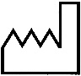 | Date of Manufacture |  | Batch Code
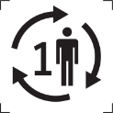 | Single Patient Multiple Use | 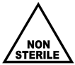 | Non-Sterile
 | Consult Instructions for Use or Consult Electronic Instructions for Use |  | Prescription Device  Caution: Federal law restricts this device to sale by or on the order of a licensed healthcare practitioner.
 | MR Unsafe

